彭冬根
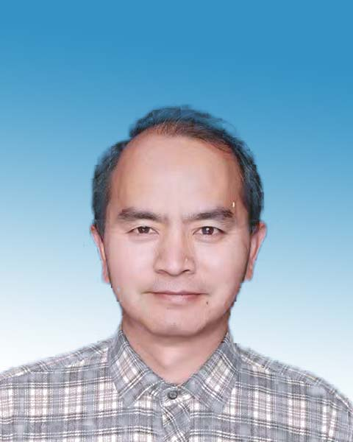
性别：男 导师类型：硕导
职称：教授 学科方向：暖通空调
学历：博士 电子邮件：ncu_hvac2013@163.com

个人简介：
教授，博士，硕士生导师，南昌大学建筑环境与节能实验中心主任，江西省土木建筑学会暖通空调热能动力专业委员会副主任委员，国家自然科学基金项目通讯评审专家，江西省科技项目（奖励）评审专家，江西省高新技术企业认定评审专家，南昌市优势科技创新团队领军人才。主要从事基于溶液除湿的室内热湿环境控制，太阳能高效热利用技术和高效复合热泵制冷制热技术的研究。

讲授课程：
传热学、空气调节、高等传热学、溶液除湿

科研项目/课题（限5项选填）：
- 国家自然科学基金项目（51266010），太阳能溶液分级集热再生与空气预除湿耦合作用机理，2013-01-01至2016-12-31，主持
- 国家自然科学基金项目（51766010），带级间热回收的太阳能分级溶液集热/再生临界性能特性及热力学优化，2018-01-01至2021-12-31，主持
- 南昌市优势科技创新团队项目（2018-CXTD-004），南昌市高效制冷知识创新团队，2018-01-01至2021-01-01， 主持
- 南昌大学产教融合研究生联合培养示范基地项目，南昌大学食品药品保质干燥联合培养示范基地，2021-11至2023-12, 主持
- 南昌大学江西省财政科技专项“包干制”试点示范项目,基于溶液除湿的空气减湿处理复合管式蒸发冷却的增强效果及机理研究, 2023-01-01至2025-12-31，主持

论文专著（限10项选填）：
(1)彭冬根，曹卓. 基于焓耗散数的绝热型溶液除湿/再生器性能预测解析模型[J].高校化学工程学报, 2022, 36(4):543-553, EI
(2)Peng Donggen, Cheng Nanyang. Experimental and CFD study on circular tube falling film dehumidification performance. Experimental Heat Transfer, 2021, 35(7): 1016-1037, SCI
(3)Peng Donggen, Cao Zhuo. Modeling and performance analysis of a hybrid-connected two-stage liquid dehumidification fresh air system based on CaCl2/LiCl double solution. Applied Thermal Engineering, 2021, 199:117529, SCI
(4)Peng Donggen, Cao Zhuo, Fu Yuting, Li Shuangling, Yang Zexaun. Applicability, performance comparison and optimization of self-preheated solar collector/regenerator. Solar Energy, 2020, 198:113-123, SCI
(5)Peng Donggen, Li Shunyi, Luo Danting, Fu Yuting, Cheng Xiaosong Liu Yin. Efficiencies comparison and performance analysis of internally-cooled liquid desiccant dehumidifiers using LiCl and CaCl2 aqueous solutions. Zhejiang Univ-Sci A (Appl Phys & Eng), 2020, 21(1):44-63, SCI
(6)彭冬根，徐少华. 蒸发冷却条件下管内LiCl 和CaCl2溶液降膜除湿性能对比.化工学报, 2020, 71(4):1554-1561, EI
(7)Peng Donggen, Xu Shaohua, Yang Hongxing. Heat and mass transfer characteristics and dehumidification performance improvement of an evaporatively-cooled liquid Dehumidifier. Applied Thermal Engineering, 2020, 178:115579, SCI
(8)Cheng Xiaosong, Peng Donggen (通讯作者), Yin Yonggao, Xu Shaohua, Luo Danting. Experimental study and performance analysis on a new dehumidifier with outside evaporative cooling. Building and Environment, 2019, 148: 200-211, SCI
(9) Peng Donggen, Cheng Xiaosong, Li Shuangling, Zhang Xiaosong, Luo Danting. Mathematical model and performance analysis of a novel outside evaporative cooling liquid desiccant dehumidifier. International Journal of Refrigeration, 2017, 82:212-226, SCI
(10)Peng Donggen, Luo Danting, Cheng Xiaosong. Modeling and performance comparisons of the grading and single solar collector regenerator systems with heat recovery. Energy, 2018, 144:736-749, SCI

